**Java Set Interface**

The Set interface of the Java Collections framework provides the features of the mathematical set in Java. It extends the Collection interface.

Unlike the List interface, **sets cannot contain duplicate elements.**

## Classes that implement Set

Since Set is an interface, we cannot create objects from it.

In order to use functionalities of the Set interface, we can use these classes:

* HashSet
* LinkedHashSet
* EnumSet
* TreeSet

These classes are defined in the Collections framework and implement the Set interface.

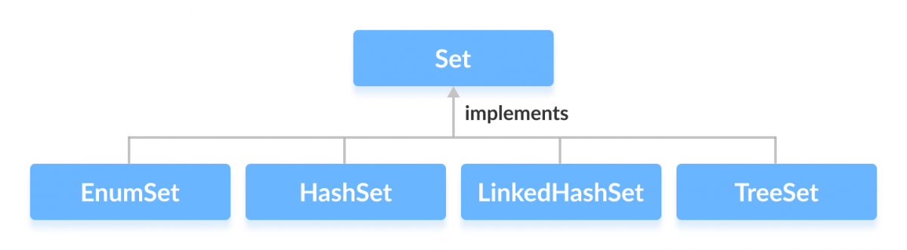

## Interfaces that extend Set

The Set interface is also extended by these subinterfaces:

* SortedSet
* NavigableSet

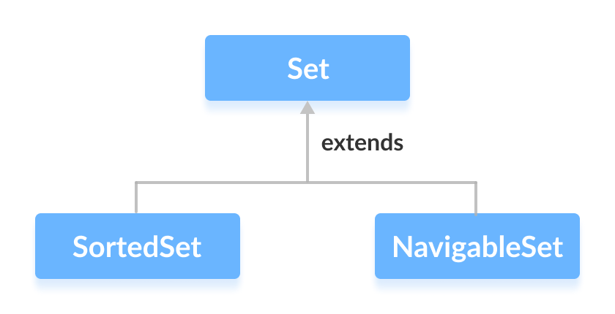

## How to use Set?

In Java, we must import java.util.Set package in order to use Set.

// Set implementation using HashSet

Set<String> animals = new HashSet<>();

Here, we have created a Set called animals. We have used the HashSet class to implement the Set interface.

## Methods of Set

The Set interface includes all the methods of the Collection interface. It's because Collection is a superinterface of Set.

Some of the commonly used methods of the Collection interface that's also available in the Set interface are:

* **add()** - adds the specified element to the set
* **addAll()** - adds all the elements of the specified collection to the set
* **iterator()** - returns an iterator that can be used to access elements of the set sequentially
* **remove()** - removes the specified element from the set
* **removeAll()** - removes all the elements from the set that is present in another specified set
* **retainAll()** - retains all the elements in the set that are also present in another specified set
* **clear()** - removes all the elements from the set
* **size()** - returns the length (number of elements) of the set
* **toArray()** - returns an array containing all the elements of the set
* **contains()** - returns true if the set contains the specified element
* **containsAll()** - returns true if the set contains all the elements of the specified collection
* **hashCode()** - returns a hash code value (address of the element in the set)

To learn about more methods of the Set interface, visit Java Set.

## Set Operations

The Java Set interface allows us to perform basic mathematical set operations like union, intersection, and subset.

* **Union** - to get the union of two sets x and y, we can use x.addAll(y)
* **Intersection** - to get the intersection of two sets x and y, we can use x.retainAll(y)
* **Subset** –(Boolean) to check if x is a subset of y, we can use y.containsAll(x)

## Implementation of the Set Interface

**1. Implementing HashSet Class**

import java.util.Set;

import java.util.HashSet;

class Main {

public static void main(String[] args) {

// Creating a set using the HashSet class

Set<Integer> set1 = new HashSet<>();

// Add elements to the set1

set1.add(2);

set1.add(3);

System.out.println("Set1: " + set1);

// Creating another set using the HashSet class

Set<Integer> set2 = new HashSet<>();

// Add elements

set2.add(1);

set2.add(2);

System.out.println("Set2: " + set2);

// Union of two sets

set2.addAll(set1);

System.out.println("Union is: " + set2);

}

}

**Output**

Set1: [2, 3]

Set2: [1, 2]

Union is: [1, 2, 3]

To learn more about HashSet, visit Java HashSet.

**2. Implementing TreeSet Class**

import java.util.Set;

import java.util.TreeSet;

import java.util.Iterator;

class Main {

public static void main(String[] args) {

// Creating a set using the TreeSet class

Set<Integer> numbers = new TreeSet<>();

// Add elements to the set

numbers.add(2);

numbers.add(3);

numbers.add(1);

System.out.println("Set using TreeSet: " + numbers);

// Access Elements using iterator()

System.out.print("Accessing elements using iterator(): ");

Iterator<Integer> iterate = numbers.iterator();

while(iterate.hasNext()) {

System.out.print(iterate.next());

System.out.print(", ");

}

}

}

**Output**

Set using TreeSet: [1, 2, 3]

Accessing elements using iterator(): 1, 2, 3,

Now that we know what Set is, we will see its implementations in classes like EnumSet, HashSet, LinkedHashSet and TreeSet in the next tutorials.